Order Lifecycle Management
- Order Creation: When a buyer completes a checkout, the system aggregates items from the shopping cart, generates a master order record, and breaks it down into individual line items assigned to their respective store vendors.
- Inventory Deduction: Item quantities are automatically deducted from the store's listed stock to prevent overselling.
- Fulfillment Updates: As vendors prepare and dispatch packages, they update the order status, attach carrier tracking information, and notify the customer.
- Post-Purchase Feedback: Once an order is marked as delivered, the system enables verified review status for the buyer, allowing them to post authentic feedback regarding the product and seller service.
Tracking
Accurate tracking keeps store inventory updated and provides buyers and merchants with visibility into order fulfillment.
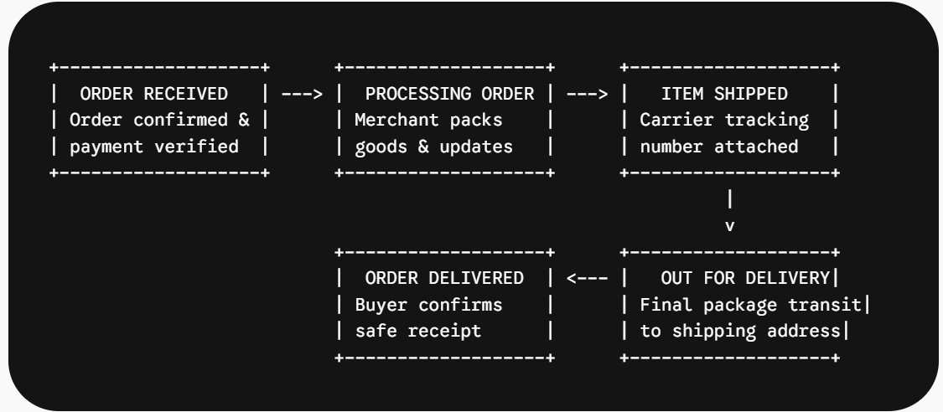
Payment and Secure Transacting
Handling payments safely requires careful coordination between the customer's browser, the application database, and external payment processors.
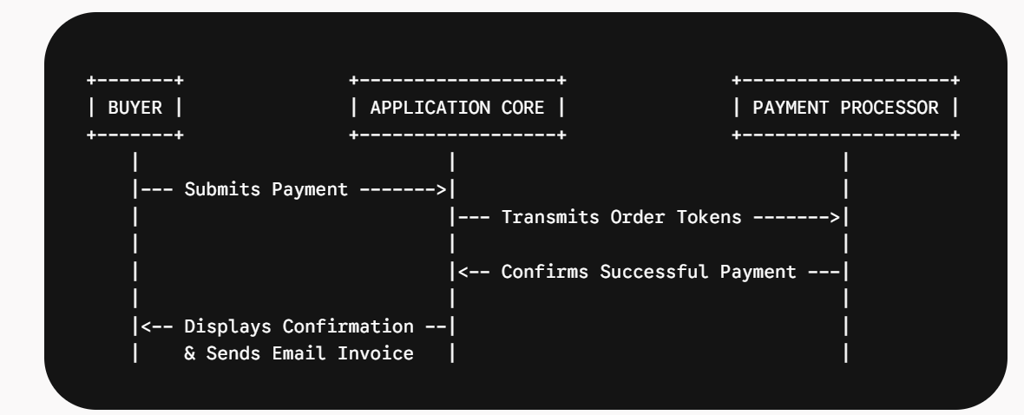

Transaction Workflow
To protect sensitive financial information:
- Credit card numbers are never stored directly on the platform's servers. Instead, payment details are transmitted securely to certified external payment gateways.
- Upon receiving payment verification from the external processor, the system completes the transaction within an isolated database operation, creates the permanent order records, clears the buyer's temporary cart, and generates an itemized invoice sent via email.

